**NEPAL COLLEGE OF INFORMATION TECHNOLOGY**

**BALKUMARI LALITPUR**



**(Affiliated To Pokhara University)**

**SUBJECT : Database Management System**

**LAB REPORT # 5**

**TITLE :** Views

**Submitted By : Submitted To :**

**Name :** Pradip Dhungana **Name :** Amit K. Shrivastava

**Roll No :** 201751 **Department of Software**

**Semester :** 4th  **Date :** 2023/07/04

OBJECTIVE

To create and manipulate various database objects of table using views.

LAB EXERCISE :

* Creating a Database named ‘lab5’.

= create database lab5;

= use lab5;

**OUTPUT :**

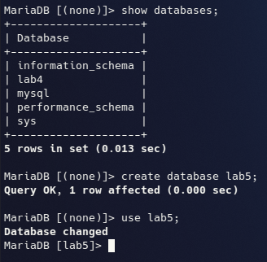

* Creating Tables and Inserting data.

**1) Customer Table :**

= CREATE TABLE customer ( cid INT, name VARCHAR(50), age INT, address VARCHAR(50), salary DECIMAL(10, 2) );

**2) Order Table :**

= CREATE TABLE `order` ( oid INT, order_date DATETIME, cid INT, amount DECIMAL(10, 2) );

**3) Employee Table :**

= CREATE TABLE employee ( eid INT, ename VARCHAR(50), job VARCHAR(50), did INT, salary DECIMAL(10, 2) );

**4) Department Table :**

=CREATE TABLE department ( did INT, dname VARCHAR(50), location VARCHAR(50) );

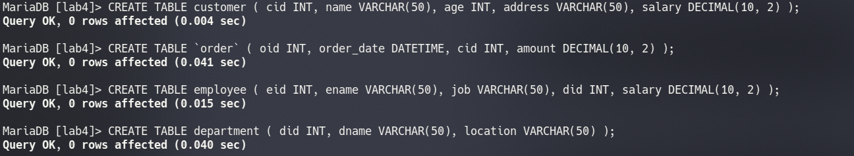 **OUTPUT :**

INSERTING DATA :

**“As the tables and data used in lab5 are the same as those used in lab4, they are used here.”**  
**1) Customer Table :**

**=** INSERT INTO customer VALUES (1, 'ram', 32, 'kathmandu', 2000.00), (2, 'shyam', 25, 'patan', 1500.00), (3, 'hari', 23, 'dharan', 2000.00), (4, 'gopal', 25, 'pokhara', 6500.00), (5, 'sita', 27, 'bhaktapur', 8500.00), (6, 'gita', 22, 'illam', 4500.00), (7, 'rita', 24, 'banepa', 10000.00);

**2) Order Table :**

**=** INSERT INTO order VALUES (102, '2015-10-08 00:00:00', 3, 3000), (100, '2014-10-08 00:00:00', 3, 1500), (101, '2014-11-20 00:00:00', 2, 1560), (103, '2013-05-20 00:00:00', 4, 2060);

**3) Employee Table :**

**=** INSERT INTO employee VALUES (1, 'arjun', 'AP', 1, 10000.00), (2, 'rabi', 'JP', 2, 12000.00), (3, 'rohan', 'AP', 2, 15000.00), (4, 'krishna', 'AP', 1, 20000.00);

**4) Department Table :**

= INSERT INTO department VALUES (1, 'accounting', 'kathmandu'), (2, 'sales', 'patan'), (3, 'research', 'banepa'), (4, 'operations', 'bhaktapur');

**OUTPUT :**

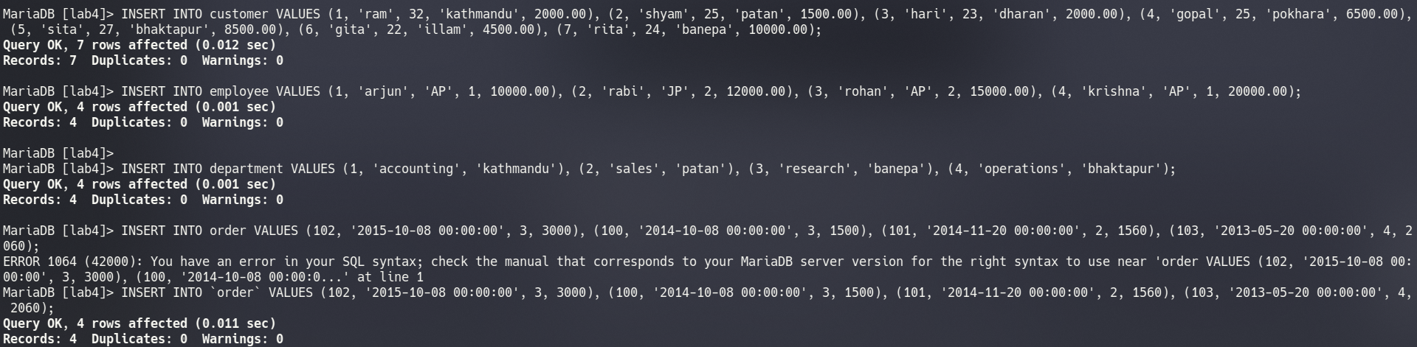

1) Use view to display only the details of employees who are AP.

= CREATE VIEW view1 as (SELECT * FROM employee WHERE job='AP');

= SELECT * FROM view1 WHERE job = 'AP';

OUTPUT :

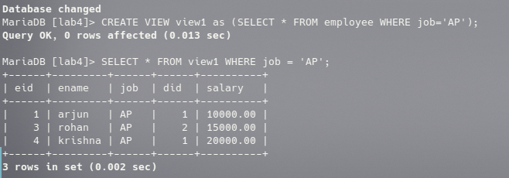2) Use view to display only name, salary and department of employee whose salary is greater than 10000.

= CREATE VIEW view2 as (SELECT ename,salary,did FROM employee WHERE salary>10000);  
 = SELECT * FROM view2;

OUTPUT :

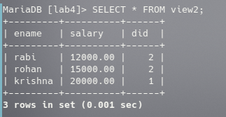

3) Use view to display name, age of customer as well as order date and amount.

= CREATE VIEW view3 as (SELECT name,age,order_date,amount FROM customer INNER JOIN `order` ON customer.cid=order.cid);

= SELECT * FROM view3;

OUTPUT :

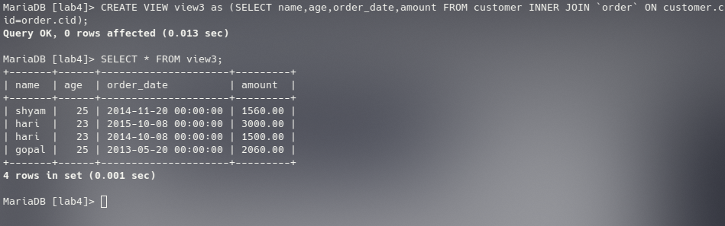

4) Update view of Q.N.3 to include address and salary of customer.

= SELECT customer.cid, customer.name FROM customer INNER JOIN `order` ON customer.cid = order.cid;

= SELECT * FROM view3;

OUTPUT:

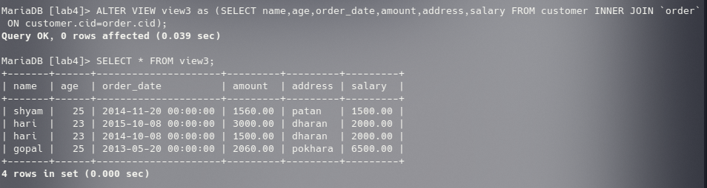5) Again update view of Q.N.4 to include only salary greater than 5000.

= ALTER VIEW view3 as (SELECT name,age,order_date,amount,address,salary FROM customer INNER JOIN `order`ON customer.cid=order.cid WHERE salary>5000);  
 = SELECT * FROM view3;

OUTPUT :

